**As an executive benefits advisor to 20% of the AM Law 50**, we wanted to bring to your attention a pressing issue that may not be immediately visible but is critically impactful: the pace at which traditional Long-Term Disability (LTD) benefits are being outstripped by rising wages and inflation. This gap poses a significant risk to Partners and staff who might find themselves unprotected in the event of disability. This article serves as a call to action for law firms to proactively address and revamp their disability benefits plans.

Key Issues

1. **Stagnant Disability Plan:** Despite substantial growth in wages, especially within law firms, LTD benefits have not been proportionately adjusted, leading to a disparity between current earnings and potential disability benefits.
2. **Inflation Outpacing Benefits:** The eroding effect of inflation on disability benefits is a concern for all employees, but it is particularly acute for high earners who rely on maintaining their standard of living.
3. **Risk to Financial Security:** The insufficient adjustment of disability benefits places employees at financial risk should they become unable to work for an extended period due to an accident or illness, potentially affecting their livelihood and the firm's morale and productivity.

Key Actions

1. **Assess the Current Benefits Gap:** Law firms should conduct a thorough evaluation of their current LTD benefits to gauge the extent of the coverage disparity, considering not just base pay but also the value of benefits over time.
2. **Update Coverage Amounts:** It's crucial to adjust the coverage amounts of LTD benefits in line with current wage levels and living costs. This recalibration should consider how base pay and benefits have evolved over periods like 5, 10, or 15 years.
3. **Consider Supplementary Plans:** Employers are encouraged to introduce employer-funded Guaranteed Issue Individual Disability (IDI) plans for high earners. These plans address the inadequacies of group LTD benefit plans, which are often not increased due to various constraints such as availability of higher limits and potential rate impacts from larger claims.
   * **Census Enrollment:** Adoption of these plans can be streamlined for benefit administrators, simplifying the integration process.
   * **Multi-Life Discounts:** With discounts up to 50%, these plans become significantly more accessible, offering a cost-effective solution to enhance coverage levels.
   * **Guaranteed Level Premiums:** This feature allows firms to increase coverage without the premium volatility that is typically associated with group plans, ensuring more predictable financial planning.
4. **Regular Benefits Review:** Establish a systematic review process for disability benefits, ensuring they remain aligned with economic changes, including wage increases and inflation.

Next steps

For law firms, the integrity of their disability benefits plan is more than just a matter of employee welfare; it represents a commitment to the team's well-being and professional security. The current landscape, highlighted by the failure of many firms to adjust their group LTD benefit plans despite rising wages and inflation, underscores the urgency of action. By adopting supplementary guaranteed issue individual disability plans, firms can offer a more robust safety net for their high earners, mitigating the risks posed by inadequate coverage.

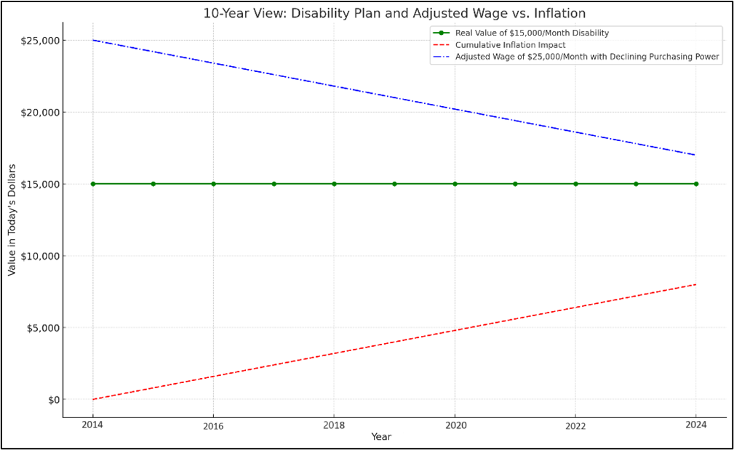The enclosed chart underscores the crux of our message with alarming clarity.

* Green Line: Over the past decade, the real value of a $15,000/month disability plan has not been adjusted.
* Blue Line: Adjusted wage of $25,000/month has seen its purchasing power diminish dramatically.
* Red Line: Inflation has increased significantly over the last 10 years.

This showcases the need for law firms to take immediate action, ensuring their disability benefits are recalibrated to truly protect their employees' current and future financial wellbeing.

Get In touch

Take the lead in safeguarding your team's future. For a thorough evaluation of your firm's disability benefits and a tailored strategy to update your coverage, contact Peck Financial today. Our expertise is your peace of mind.

Reach us at [jpeck@peckfinancial.com](mailto:jpeck@peckfinancial.com) for a detailed consultation.